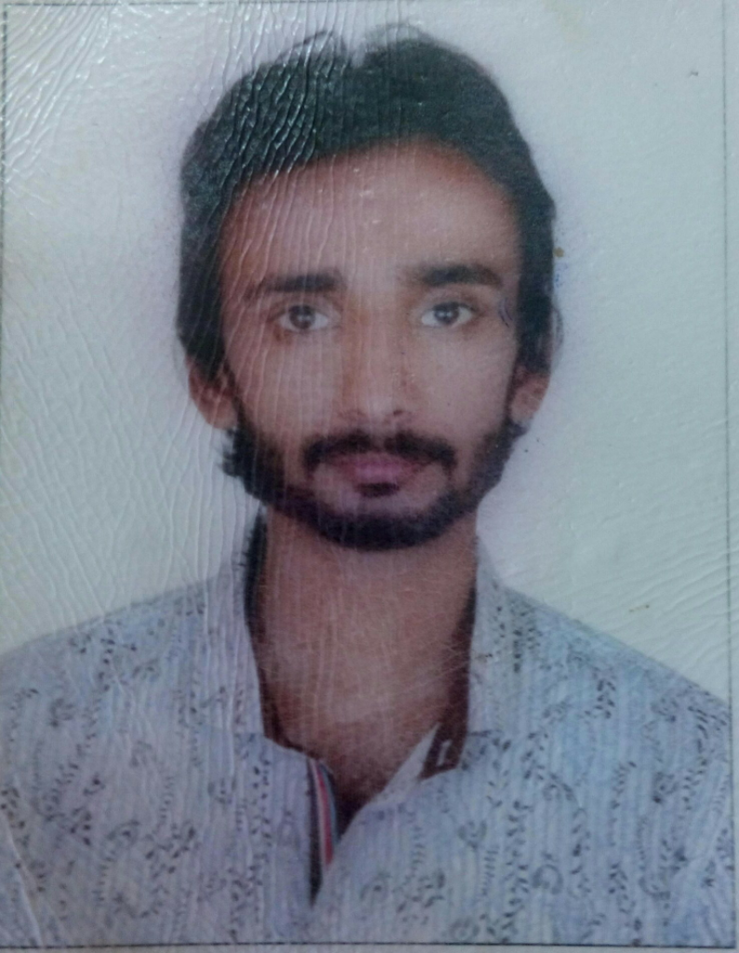

Danish Munir
- Postal Address: Gillani Town, Mandi Bahauddin
- Contact No: +971561836766
- Email add: danishmunir618@gmail.com

I would dedicate myself towards the achievement of company’s objectives while being a part of it and would carry out my duties responsibility, while maintaining excellent interpersonal relationships with my fellow workers.

PERSONAL DETAILS

- Name : Danish Munir
- Father’s Name : Munir Ahmed
- N.I.C : 784-1992-2972190-9
- Date of Birth : 04-06-1992
- Religious : : Islam
- Marital Status: : Single
- Address: Mandi Bahauddin (Punjab)
- Nationality: Pakistani

Diploma | Result | Year | Board/University
Civil Surveyor Trade | Excellent | 2012 | Punjab Board Of Technical Education Lahore.

LANGUAGES

1) Urdu 2) Punjabi 3) English : Read Write & Speak

ADDITIONAL COURSES

- (1) Office Management
- (2) Autocad
- (3) Computer Software/Hardware
EXPERIENCE HISTORY
- 2 years UAE Experience as a Store Keeper in (UMR UAE).
- 1 year UAE Experience as Surveyor.
KEY SKILLS
- Good time management skillS.
- HIgh commitment in teamwork.
- Good communication and interpersonal.
- Ability to work under pressure.
- Ability to work in any suitable field.

